 |  | 
Information Society Technologies Programme (IST)
Accompanying Measure
Project Number: | IST-1999-14106
Project Acronym: | WISTCIS
Project title: | New Methods of Working for Information Society Technologies Programme Promotion to Commonwealth of Independent States”
Project Co-ordinator: | Jean Bonnin (EDNES)
Project Manager: | T. Shulyakovskaya (EDNES)
Deliverable Title: | Implementation of multilingual Collaborative Browsing User Agent for EU-CIS work
Deliverable Number: | D9
Authors:  Contributions: | Holger Christein, University of Ulm  Anatoly Soloviev, CGDS Moscow
Date: | May 30, 2002

Executive Summary
Presence Awareness lets people realize who else is around. In the web context Presence Awareness allows people to ‘see’ each other while they are browsing the same web page or web site. This fundamental property of Presence Awareness enables ad-hoc communication of people and also more substantial communication since people with similar interests meet on the same web locations.
When installed at IDCs it will ease the getting in touch between people from EU and CIS working in research, education, business or just between people who are simply browsing the web for fun. This is because Presence Awareness provides for encounters similarly like in the real world.
This report focuses on implementation of a multilingual Collaborative Browsing User Agent (CBUA), which will support Russian language so that it is well fitting for use within the CIS countries. To allow EU-CIS team work in areas such as research and education it will also support the English language.
In the following we give an overview of the Presence Awareness service developed by Ulm University, which is the backbone of CBUA currently compiled in the framework of the WISTCIS project. Then we discuss the main implementation issues of CBUA. Finally we conclude with a sample of important current screen shots of it. Here we use to opportunity to describe prominent functionality of CBUA.
WISTCIS
Implementation of multilingual Collaborative Browsing User Agent

30.05.2002

Table of Contents

1. Presence Awareness Information Broker (PAIB) (former Virtual Presence System) 5
1.1 Overview 5
2. Collaborative Browsing User Agent (CBUA) 7
2.1 Overview 7
2.2 Displaying neighboring users 7
2.3 Multilinguality 9
2.4 Current Screen Shots 10
2.4.1 Login Window 10
2.4.2 CBUA Main Window 11
2.4.3 Properties Window 12
2.5 Current State of Implementation 13
3. References 14
Annex I: Software test report 15

Presence Awareness Information Broker (PAIB) (former Virtual Presence System)

Overview
The new multilingual Collaborative Browsing User Agent, which will be named CBUA in the following, is based on the PAIB (Presence Awareness Information Broker) service [1] developed by Ulm University. PAIB can be regarded as a successor of the CoBrow system.
PAIB in general delivers Presence Awareness information of vicinities [2] or in other words it tells which users are within a certain neighborhood. It thus allows tracking of vicinities. A neighborhood in the context of collaborative Browsing are users who have opened the same web page or related web pages, e.g. web pages of a web site. As a default means of communication PAIB provides chat functionality. Chats refer either to all users within a neighborhood or to a selected user. In addition to CoBrow it allows also tracking of presence information of single users (or presentities [2]). Furthermore it provides status information of users like ‘user is busy/idle’. So overall it tells who is around and what people being around are doing.
Since it is completely implemented in Java, it can be installed on every operating system that provides a Java virtual machine (every relevant operating system provides a Java virtual machine meanwhile).
The database layer where properties of users like photos, names, e-mail addressed etc. are stored has become much more flexible. Now even pre-existing LDAP databases with arbitrary schemes can be imported in the PAIB simply by providing a scheme description in XML style to PAIB. Databases, which implement LDAP (Lightweight Directory Access Protocol), store their data in a hierarchical manner.
Figure 1 displays an overview of the architecture of PAIB. PAIB has client/server architecture with a lean client side API. CBUA makes use of this API.

LDAP
SQL
...
Server Side Presence Manager
delivers Presence Awareness information and user properties
RMI
SIP variant/...
Database Scheme Description
(XML)
Vicinity Calculations
presentity/ vicinity based Presence Awareness; status of presentities;
Server Side Protocol Stack
RMI/SIP variant/…
Client Side Presence Manager
JNDI
JDBC
…
Client side
Database Layer SPI
deals with different database systems and schemes; delivers unstructured results;

Database Layer API
delivers structured data (user records, user information);
(
Client Side Protocol Stack
RMI/SIP variant/…
Server side

Figure 1: PAIB Overview

Collaborative Browsing User Agent (CBUA)

Overview
The communication between a CoBrow user agent and its Presence Awareness service is done via a dedicated protocol, which is transmitted over HTTP. Additionally to the Presence Awareness service at server side there is a web server specific plug-in. This is in fact a dll (dynamic link libraries) that implements some kind of web server specific API. Its main task is to add some Java Script code. This piece of code which we call scout tells the Presence Awareness service which web page is currently viewed by a user.
The communication between CBUA and PAIB is done via the client side API of PAIB. This is no problem since CBUA is a Java Applet and not HTML as in case of the CoBrow user agent. Instead of using web server specific plug-ins for WISTCIS we use a Java Proxy Servlet, which does a little bit more than just adding the scout to a requested web page. The result is that Presence Awareness is not only related to a specific web site but to the whole web. Again with Java Servelts we remain in the Java world, which provides the platform independency. It is, of course, possible to use CBUA for a dedicated site only, too.
Figure 2 shows the whole system currently compiled for WISTCIS, which consists of PAIB and the Proxy Servlet at server side and CBUA at client side.

Displaying neighboring users
To display neighbouring users CBUA has to know which URL or web page is currently viewed by its user. Therefore CBUA subscribes to Presence Awareness information of its user at the PAIB service with aid of PAIB’s client side API. This means that CBUA gets a notification whenever its user opens another web page. Each time it gets a notification CBUA subscribes to Presence Awareness information of the web page currently viewed by its user. Thereby the PAIB service delivers initially all current neighbouring users, as well as changes, thus users who have entered the neighbourhood, as well as users who have left.
To make the whole thing work, the web page currently viewed by a user has to be reported to the PAIB service. This is a two-step process: first the scout has to be added to each retrieved web page. Second the scout reports the URL of a retrieved web page to its PAIB service.
There are two ways of adding the scout to a web page: first it can be done in advance by the creator of a web page or by some process which does it for all web pages of a web site. This solution is bad since web pages have to be changed and it works not with web pages where it was forgotten to add it (or which do not know about our system). For WISTCIS we have implemented a special Proxy Servlet, which tunnels each request and response. Before a response or a web page is send to a client’s browser, the scout is added to it. If a user follows a link within a web page it must be ensured that this link is tunnelled through the Proxy Servlet so that it can do its job. Therefore each link has to be rewritten. This is also done by the Proxy Servlet. The following example shows what the Proxy Servlet does:

Figure 2: System Overview


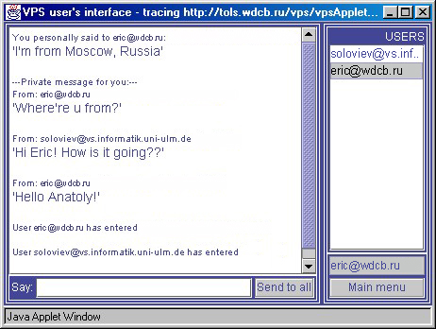
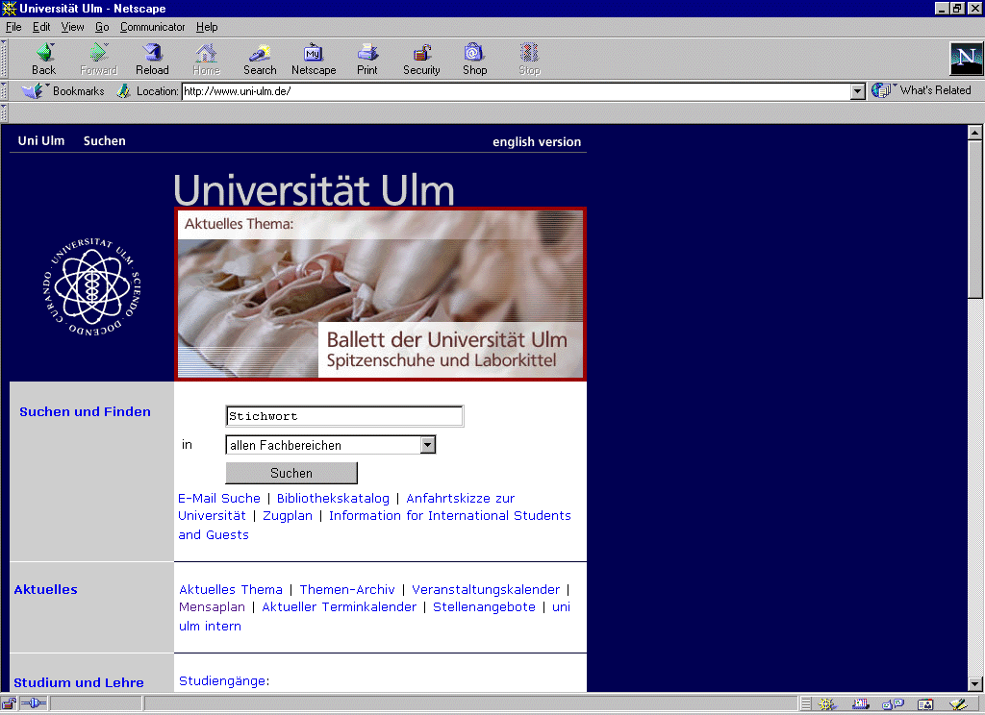
..
PAIB
Servlet Engine
Proxy Servlet
CBUA Window
Browser Window
HTTP Request/ Response tunneled through Proxy Servlet
Reports user’s current URL
Retrieves users located at/ neighbouring to user’s current URL
Web Site
Web Site
Web Site
Client Side
Server Side
Actual HTTP Request/ Response
//original link within a web page
<A HREF="http://www.uni-ulm.de"></A>
..

..
//that’s how the link looks like after the Proxy Servlet
//has changed it:
<A HREF=
"http://cyclone.informatik.uni-ulm.de/
proxy/http://www.uni-ulm.de">
</A>
//This means that at host cyclone a Proxy Servlet is
//running which tunnels the request for web page
//www.uni-ulm.de de.
..

The scout, which is added by the Proxy Servlet is in fact a small Java Applet. So this add-on looks like this in the code of a requested web page:

<applet
code = scout.class
codebase=
”http://cyclone.informatik.uni-ulm.de/codebase/”>
</applet>

Every Applet implements two so called call-back methods namely start() and stop().
The start() method is called whenever the belonging web page is opened. Within the implementation of this method the scout Applet tells its PAIB service, with aid of PAIB’s client side API, that just this has happened. Other users who are within the same neighborhood get a notification from their CBUA that a new user has joined.
The stop() method is called whenever the current page is replaced by another page or in other word whenever the user opens another web page. Similar to the start() method the scout Applet reports again its PAIB service what has happened. Again other users get a notification from their CBUA that the user has left if the new web page is not neighboring.
The discussion above states that PAIB’s client side API object is shared by the scout Applet and by CBUA, which is also an Applet. This is possible since it is globally available and is realized in Java by static fields.

Multilinguality
To internationalize CBUA we have to provide translations for every text label that appears at the GUI. The Java programming language provides therefore the commonly used resource bundles. For each supported language, at least Russia and English, there is a separate resource bundle, which contains the appropriate translations. A fully qualified resource bundle name has the form bundle_la_CO whereas bundle is the name of the resource bundle, la is the two letter language code and CO the two letter country code. For example a user living in Russia speaking Russian decides to have a Russian CBUA. Therefore he would select Russian language at the corresponding control of CBUA and internally the resource bundle cbuaLabels_ru_RU would be loaded.
It is sufficient if the user only selects the desired language since the country is known by CBUA. Differentiating not only between languages but also between countries makes it possible to support e.g. American English respectively British English. Additionally resource bundles provide flexible lookup functionality. If someone living in Great Britain decides to have an English CBUA and there is no cbuaLabels_en_GB resource bundle available but a cbuaLabels_en this one would be loaded into the system automatically.
Using of resource bundles makes the task of internationalization quite easy and beyond it supporting of other languages can be done rather quickly at any time simply by adding new resource bundles containing the corresponding translation. The System currently compiled for the WISTCIS project makes this task even more easier simply by storing translations within files which are located at server side. So providing a new translation is simply editing a new file and not compiling a new Java class. Editing files can be done be nearly everyone whereas compiling Java classes can be done only by people experienced with the Java programming language.

Current Screen Shots
In the following there is a selection of important current screen shots of the CBUA.

Login Window
Figure 3 displays the login window of CBUA. There are two kinds of Login. The first kind only requests a user name and the password of a user. This login is used when the user is already known by the CBUA. The second kind of login requests besides a user name and the belonging password the properties of a user (Figure 3 requests properties homepage, e-mail address, phone number and postal address). In this case the new user logs on to CBUA and is also created. This second kind of login should be the normal case since also web users browsing the CBUA accidentally might participate. By simple login they can.

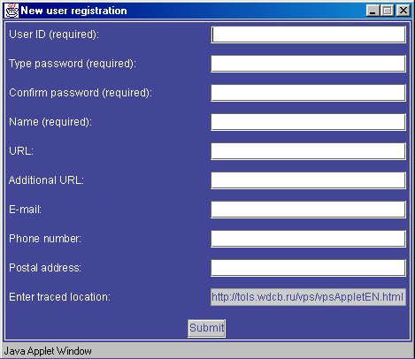

Figure 3: Login Window

CBUA Main Window
Figure 4 Displays the CBUA Main Window. It displays the User IDs of neighboring users (alphabetically sorted), the URL of the web page currently viewed by the user and the chat history. It provides an input field for entering chat. A chat message can be either sent to all neighboring users or to only one certain user.

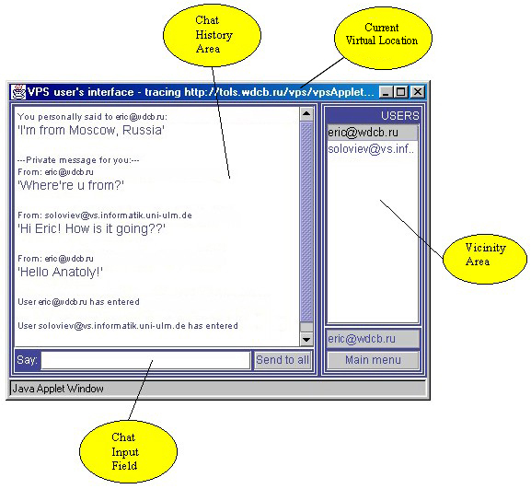

Figure 4: CBUA Main Window

Properties Window
Figure 5 displays the properties of a user. If a user displays his own properties they are editable. If properties of other users are viewed they can’t be changed. This prevents malicious users from changing properties of other users while a user whose e.g. phone number or mail address has changed is able to update the corresponding information within CBUA at any time.

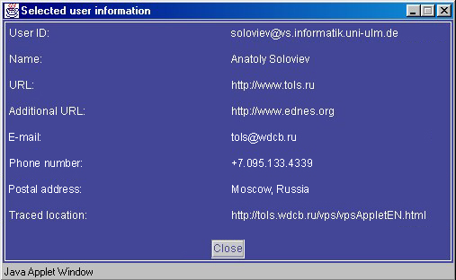

Figure 5: Properties Window

Current State of Implementation
A great deal of work is already done. Displaying of neighbouring users as described in chapter 2.2 is completely implemented and works quite well. Multilanguality is also ready to use. Most of the necessary functionality is available as chapter 2.2 points out. For oncomming reporting periods there are anyway still some tasks to do. The whole system has to be installed at the WISTCIS main web site. Therefore a Servlet engine, as well as a LDAP database, which stores the user properties, have to be set up. We plan to deploy the latest Version of PAIB. CBUA has to be adopted to some changes within the current client side API of PAIB in order to make use of it. The final step is the rollout where the whole system is installed at different IDCs (Azerbaijan, Belarus, Moldova, Ukraine).
Besides the work described above the following milestones which are named in workpackage WP 4 have alredy been reached: Demonstration of CoBrow at WISTCIS kick-off conference and at the two WISTCIS conferences in 2001. The requirements of collaborative browsing for EU-CIS teamworks have been defined and are taken into account in the so far compiled CBUA.

References
[1] PAIB on the web: http://www-vs.informatik.uni-ulm.de/virtual_presence/

[2] A General Purpose Model for Presence Awareness; Holger Christein, Peter Schulthess, University of Ulm, Germany; To appear in the Proceedings of the 4th International Conference on Distributed Communities on the Web, Sidney, Australia, 2002

Annex I: Software test report

Anatoly Soloviev

User Requirements and Tools Anaysis

Introduction
This is test report on “Pilot/Test” phase of the subcontract implementation. The compiled software implements the main functionality of the Presence Awareness Information Broker.

Definitions, Acronyms and Abbreviations
CBUA = Collaborative Browsing User Agent
PAIB = Presence Awareness Information Broker
WS = Web-site, which is supposed to be provided with Presence Awareness
JS = Proxy-Servlet and PAIB-Servlet (which is responsible for communicating with PAIB server-part) represent one single Java-Servlet
Proxy JS = Proxy-Servlet part of JS
PAIB JS = PAIB-Servlet part of JS
ESM = Enter JavaScript Method
LSM = Leave JavaScript Method
CVL = Current Virtual Location, where the user is currently residing at (where the user has entered). This location belongs to the WS
PMC = Presence Manager Client

Testing Environment
Software: MS Windows 98; Internet Explorer 5.5/Netscape Navigator 6; JDK Runtime Environment 1.4.0
Hardware: Pentium II 300, 128Mb RAM, 8Gb HDD

Setup Information (general Pre-conditions)
- PAIB server-part, CBUA Applet and JS are located (all together) at the same server. The WS is located separately at another Web-server;
- Cookies in the browser are enabled;
- Java in the browser is enabled.

Test Cases

Test Case 1: The user opens start-page of the WS

Description
The user opens start-page of the WS. The start-page of the WS is a Web-page (which belongs to the WS), which the user should open before starting to browse the WS (this page contains the corresponding link to the WS).

Pre-conditions for this test case
none

Scenario

Test Case
UC Step | Step Description | Expected Result | Actual Result  (if different from expected) | Successful/  Failed
1 | Automatic modifying (by special Java-Script method within start-page) of the URL of currently opened Web-page to be passed through Proxy JS (this happens at the moment when start-page is opened by the user) | Currently opened Web-page is passed through Proxy JS and HTML-content is modified (it is possible to see modified links and inserted Java-Script methods by viewing HTML-content of retrieved Web-page) |  | Successful
2 | New window with language choosing opens automatically | Ability of choosing language (English/Russian) of the CBUA Applet interface on-line |  | Successful
 |  |  | Test Case Status | Successful

Test Case 2: Proxy JS modifies HTML-content of the Web-page

Description
While some Web-page is passed through Proxy JS, HTML-content of that Web-page is modified.

Pre-conditions for this test case
none

Scenario

Test Case
UC Step | Step Description | Expected Result | Actual Result  (if different from expected) | Successful/  Failed
1 | Proxy JS modifies all the links within HTML-page, related to the WS (which belong to the WS) | Web-pages, on which such links point at, will be also passed through Proxy JS (when the user clicks on such links) |  | Successful
2 | Proxy JS inserts 2 Java-Script methods (ESM and LSM) in HTML-page | Each time when the Web-page is opened, ESM is called automatically; each time when the Web-page is closed, LSM is called automatically |  | Successful
3 | The modified Web-page is sent to client by Proxy JS | The new (modified) Web-page is opened in the user’s browser window, without any visual changes (it is possible to see modified links and inserted Java-Script methods by viewing HTML-content of retrieved Web-page) |  | Successful
 |  |  | Test Case Status | Successful

Test Case 3: The user chooses preferred language in the corresponding window

Description
The user chooses preferred language, so the CBUA Applet user’s interface is displayed in his native language.

Pre-conditions for this test case
none

Scenario

Test Case
UC Step | Step Description | Expected Result | Actual Result  (if different from expected) | Successful/  Failed
1 | The user clicks on link with preferred language | The CBUA Applet starts and user’s interface (each label, button, title, etc.) is displayed in the specified language |  | Successful
 |  |  | Test Case Status | Successful

Test Case 4: Logging on to the PAIB system as an existing user

Description
When the CBUA Applet is started, first of all the user has to log on to the PAIB system. In this Test Case we suppose, that the user is already known by the system.

Pre-conditions for this test case
none

Scenario

Test Case
UC Step | Step Description | Expected Result | Actual Result  (if different from expected) | Successful/  Failed
1 | The user types in his User ID and password and presses ‘Login’ button | The user logs on to the system with the specified User ID and password |  | Successful
 |  | The user’s session information (User ID, password and session context no.) is written into cookie |  | Successful
 |  | The user enters (by means of the CBUA Applet) initial location - at this moment, CVL - is the CBUA Applet parent Web-page (initial location). The CBUA Applet shows group of users, who are also residing at this initial location |  | Successful
 |  |  | Test Case Status | Successful

Test Case 5: Logging on to the PAIB system as a new user

Description
When the CBUA Applet is started, first of all the user has to log on to the PAIB system. In this Test Case we suppose, that the user is not known yet by the system, so it’s necessary for him to register in the system.

Pre-conditions for this test case
none

Scenario

Test Case
UC Step | Step Description | Expected Result | Actual Result  (if different from expected) | Successful/  Failed
1 | The user presses ‘New user’ button | New user registration form is opened with fields (to be filled by the user), taken from LDAP scheme information, which form User Properties |  | Successful
2 | The user fills the registration form (including specifying unique User ID and password); the user presses submit button | Specified User’s Properties are stored in LDAP database (after that the user is considered to be registered user in the system) |  | Successful
 |  | The registration form is disappeared |  | Successful
 |  | The user logs on to the system with the specified User ID and password |  | Successful
 |  | The user’s session information (User ID, password and session context no.) is written into cookie |  | Successful
 |  | The user enters (by means of the CBUA Applet) initial location - at this moment, CVL - is the CBUA Applet parent Web-page (initial location). The CBUA Applet shows group of users, who are also residing at this initial location |  | Successful
 |  |  | Test Case Status | Successful

Test Case 6: The user browses the WS

Description
The user clicks some link at some Web-page within the WS (Web-page A), which points at the Web-page, which also belongs to the WS (Web-page B). For this purpose the user may press browser’s navigation buttons (‘Back’ and ‘Forward’).
Note: Web-page B will be also passed through Proxy JS (see 4.2.3, Step 1).

Pre-conditions for this test case
none

Scenario

Test Case
UC Step | Step Description | Expected Result | Actual Result  (if different from expected) | Successful/  Failed
1 | The LSM from the Web-page A is called | It reports to the PAIB JS URL location of the Web-page A, session information (read from cookie), command name (‘Leave Location’ command) and host-name, where PAIB server-side is running |  | Successful
2 | Web-page B opens | HTML-content of Web-page B is modified, because it has been passed through Proxy JS (it is possible to see modified links and inserted Java-Script methods by viewing HTML-content of retrieved Web-page B) |  | Successful
3 | The ESM (within Web-page B) is called | It reports to the PAIB JS URL location of the Web-page B (CVL), session information (read from cookie), command name (‘Enter Location’ command) and host-name, where PAIB server-side is running |  | Successful
 |  |  | Test Case Status | Successful

Test Case 7: PAIB JS receives ‘Enter Location’ command (for the first time)

Description
PAIB JS receives ‘Enter Location’ command each time some Web-page of the WS is opened.

Pre-conditions for this test case
The user is already logged on to the PAIB system by means of the CBUA Applet (if not – nothing happens).

Scenario

Test Case
UC Step | Step Description | Expected Result | Actual Result  (if different from expected) | Successful/  Failed
1 | PAIB JS creates the corresponding PMC object (based on session information) and stores it in the HttpSession object | The user logs on to the system with the specified User ID, password and session context no. |  | Successful
2 | PAIB JS reports to the PAIB server-side entering CVL | The CBUA Applet of each user (who are residing at CVL) receives this notification (about entering) from the PAIB server-side and displays new group of users, who are residing at CVL |  | Successful
 |  |  | Test Case Status | Successful

Test Case 8: PAIB JS receives ‘Enter Location’ command (not for the first time)

Description
PAIB JS receives ‘Enter Location’ command each time some Web-page of the WS is opened.

Pre-conditions for this test case
- The user is already logged on to the PAIB system by means of the CBUA Applet (if not – nothing happens);
- The user has not already entered this location (if yes – nothing happens).

Scenario

Test Case
UC Step | Step Description | Expected Result | Actual Result  (if different from expected) | Successful/  Failed
1 | PAIB JS searches for the corresponding PMC object (basing on session information) in HttpSession object | PAIB JS gets the corresponding PMC object from HttpSession object |  | Successful
2 | PAIB JS reports to the PAIB server-side entering CVL | The CBUA Applet of each user (who are residing at CVL) receives this notification (about entering) from the PAIB server-side and displays new group of users, who are residing at CVL |  | Successful
 |  |  | Test Case Status | Successful

Test Case 9: Leaving initial location

Description
Entering initial location was performed by means of the CBUA Applet (see Test Case 4, Test Case 5). When the user enters new location, the CBUA Applet has to perform leaving initial location by itself. The reason is that the CBUA Applet parent Web-page (initial location) does not contain LSM inside.

Pre-conditions for this test case
none

Scenario

Test Case
UC Step | Step Description | Expected Result | Actual Result  (if different from expected) | Successful/  Failed
1 | The CBUA Applet reports to the PAIB server-part leaving initial location | The CBUA Applet of all other users (who are residing at initial location) receives this notification (about leaving) from the PAIB server-side and displays new group of users, who are residing at initial location |  | Successful
 |  |  | Test Case Status | Successful

Test Case 10: PAIB JS receives ‘Leave Location’ command

Description
PAIB JS receives ‘Leave Location’ command each time some Web-page of the WS is closed.

Pre-conditions for this test case
- The user is already logged on to the PAIB system by means of the CBUA Applet (if not – nothing happens);
- The user has already entered this location (if not – nothing happens).

Scenario

Test Case
UC Step | Step Description | Expected Result | Actual Result  (if different from expected) | Successful/  Failed
1 | PAIB JS reports to the PAIB server-side leaving CVL | The CBUA Applet of all other users (who are residing at CVL) receives this notification (about leaving) from the PAIB server-side and displays new group of users, who are residing CVL |  | Successful
 |  |  | Test Case Status | Successful

Test Case 11: The user stops browsing the WS

Description
The user stops browsing the WS in two cases – either he goes outside the WS (opens another Web-site in the same browser window), or closes the browser window with the WS.

Pre-conditions for this test case
none

Scenario

Test Case
UC Step | Step Description | Expected Result | Actual Result  (if different from expected) | Successful/  Failed
1 | The LSM from CVL is called | It reports to the PAIB JS URL of CVL, session information (read from cookie), command name (‘Leave Location’ command) and host-name, where PAIB server-side is running |  | Successful
 |  |  | Test Case Status | Successful

Test Case 12: The user sends chat message

Description
While residing at CVL the user sends a message to everybody from a group of users, who are also residing at the same location.

Pre-conditions for this test case
none

Scenario

Test Case
UC Step | Step Description | Expected Result | Actual Result  (if different from expected) | Successful/  Failed
1 | The user types in text message in the corresponding text field and presses ‘Send’ button | This event is sent to the PAIB server-side |  | Successful
 |  | The CBUA Applet of each user (who are residing at the same location) receives this notification (about incoming message) from the PAIB server-side and displays it |  | Successful
 |  |  | Test Case Status | Successful

Test Case 13: The user sends private message

Description
While residing at CVL the user sends a message to specified user from a list of users, who are also residing at the same location.

Pre-conditions for this test case
none

Scenario

Test Case
UC Step | Step Description | Expected Result | Actual Result  (if different from expected) | Successful/  Failed
1 | The user clicks at specified item (User ID) from a list of users | Pull-down menu with two items (‘Display user’s info’ and ‘Send a message to user’) appears |  | Successful
2 | The user chooses ‘Send a message to user’ item from pull-down menu | New frame with text field appears |  | Successful
3 | The user types text message in the text field and presses ‘Send’ button | This event is sent to the PAIB server-side and the frame is disappeared |  | Successful
 |  | The CBUA Applet of that specified user (who is residing at the same location) receives this notification (about incoming private message) from the PAIB server-side and displays it |  | Successful
 |  |  | Test Case Status | Successful

Test Case 14: Displaying specified User’s Properties

Description
While residing at CVL the user wishes to display specified User’s Properties from a list of users, who are also residing at the same location.

Pre-conditions for this test case
none

Scenario

Test Case
UC Step | Step Description | Expected Result | Actual Result  (if different from expected) | Successful/  Failed
1 | The user clicks at specified item (User ID) from a list of users | Pull-down menu with two items (‘Display user’s info’ and ‘Send a message to user’) appears |  | Successful
2 | The user chooses ‘Display user’s info’ item from pull-down menu | Specified User Properties retrieved from the PAIB server-side |  | Successful
 |  | New frame appears and specified User Properties are displayed in it |  | Successful
3 | The user presses ‘Close’ button | The frame is disappeared |  | Successful
 |  |  | Test Case Status | Successful

Test Case 15: Displaying/modifying own User Properties

Description
While residing at CVL the user wishes to display and modify his own User Properties.

Pre-conditions for this test case
none

Scenario

Test Case
UC Step | Step Description | Expected Result | Actual Result  (if different from expected) | Successful/  Failed
1 | The user presses ‘Main menu’ button | Pop-up menu with two items (‘Help’ and ‘Your information’) appears |  | Successful
2 | The user chooses ‘Your information’ item from pop-up menu | Own User Properties retrieved from the PAIB server-side |  | Successful
 |  | New frame appears and own User Properties are displayed in it; the values of User Properties are modifiable |  | Successful
3 | The user changes his User Properties’ values and presses ‘Save’ button | The corresponding User Record in LDAP database is updated; the frame is disappeared |  | Successful
 |  |  | Test Case Status | Successful

Test Case 16: The user opens help-page

Description
While working with the CBUA Applet, the user wishes to read user’s manual on CBUA Applet user’s interface.

Pre-conditions for this test case
none

Scenario

Test Case
UC Step | Step Description | Expected Result | Actual Result  (if different from expected) | Successful/  Failed
1 | The user presses ‘Main menu’ button | Pop-up menu with two items (‘Help’ and ‘Your information’) appears |  | Successful
2 | The user chooses ‘Help’ item from pop-up menu | An additional browser window with help Web-page appears |  | Successful
 |  |  | Test Case Status | Successful

